INDUSTRY / RESEARCH INTERNSHIP
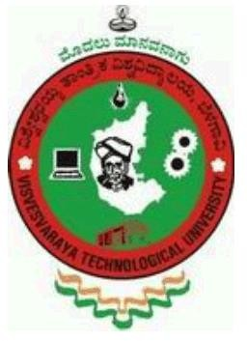
An
Internship Report Submitted To

VISVESVARAYA TECHNOLOGICAL UNIVERSITY
Belagavi, Karnataka

For The Award of Degree
Bachelor of Engineering

By
Mr. Vivek Suresh Lokolakar
USN: 2JI22CS123

Guide
Prof. Nalinakshi B G
Professor
Department of Computer Science and Engineering
Jain College of Engineering, Belagavi


Department of Computer Science and Engineering JAIN COLLEGE OF ENGINEERING (JCE)
Belagavi, Karnataka – 590014 2024-2025

JGI’s

JAIN COLLEGE OF ENGINEERING (JCE)

BELAGAVI

DEPARTMENT OF COMPUTER SCIENCE AND ENGINEERING

Certificate

Certified that Mr. Vivek Suresh Lokolakar, an undergraduate student bearing USN 2JI22CS123 has satisfactorily completed the Internship on “FullStack Development”, at JIEF Belagavi submitted to Visvesvaraya Technological University, Belagavi in partial fulfillment for the award of Bachelors in Computer Science and Engineering.

Guide Internship Co-ordinator Principal & Director

Visvesvaraya Technological University, Belagavi



CERTIFICATE
Certified that the Industry Internship

“FullStack Development”

is a bonafide work carried out by

Mr. Vivek Suresh Lokolakar
USN: 2JI22CS123

In partial fulfillment for the award of BACHELORS IN COMPUTER SCIENCE AND ENGINEERING of the Visvesvaraya Technological University, Belagavi. The report has been approved as it satisfies the academic requirements in respect of Internship Work prescribed for the said degree

Name of the Examiners Signature with date

Internship Certificate

Acknowledgements

I am grateful and would like to express my sincere gratitude to guide Prof.Nalinakshi B G. Your Guide for his untiring guidance, continuous encouragement and constant support which made this Internship study possible. Sir has impressed me with his outstanding professional conduct and his strong conviction towards the Internship study. I am truly obliged for his progressive vision throughout the internship.

I would also like to thank Principal and Director of Jain College of Engineering, Belagavi Dr. J. Shivakumar, HOD Computer Science and Engineering, Dr. Uttam Patil, Faculty of Computer Science and Engineering Department and Management of Jain College of Engineering, Belagavi, for their wisdom and valuable suggestions during my internship work. I extend my gratitude to the, Internship Co-ordinator and Staff of Jain College of Engineering, Belagavi, for their support and cooperation during the study.

I finally acknowledge my sincere indebtedness and gratitude to my parents and family for their constant support and encouragement throughout the Internship.

Vivek Suresh Lokolakar

ABSTRACT

The internship aimed to gain practical exposure to full stack web development and real-world software engineering practices. As part of this internship, an Employee and Work Order Management System was designed and developed to streamline organizational operations through digital automation.

The system functions as a mini ERP (Enterprise Resource Planning) platform, allowing administrators to manage employees, departments, and work orders efficiently. It supports role-based access control for Admin, Manager, and Employee users, ensuring secure and structured workflow management. The application integrates React for the frontend, Node.js and Express for the backend, and MongoDB as the database. Real-time notifications and updates were implemented using Socket.io, enhancing system interactivity and user experience.

This internship provided hands-on experience in modern web technologies, project structuring, deployment, and maintenance. It also strengthened understanding of teamwork, problem-solving, and the application of theoretical concepts in practical development environments. The project demonstrates how digital ERP systems can improve coordination, transparency, and efficiency in employee and work order management.

TABLE OF CONTENTS
CONTENTS Page No.

Acknowledgement
Abstract | i
Table of Contents | ii
List of Figures | v
List of Tables | xii
List of Abbreviations | xvii
Chapter 1: Industry Internship 1-6
  - : Introduction 1
  - : Objectives of Internship 4
  - : Report Outline 5
Chapter 2: Industry / Company Profile 6-20
  - : Firm History 6
  - : Management Board of the Firm 8
  - : Vision & Mission 12
  - : Products / Services 16
Chapter 3: Job Description & Internship Experience 21-35
  - : Project Description 21
  - : Software / Hardware / Design Development Process 24
  - : Project Planning & Execution 28
  - : Implementation, Testing & Documentation 31

  - Deployment and Maintenance 32
  - Images (field images of Internships with GPS) 34
Chapter 4: Internships Learning’s & Findings 36-50
  - : Types of Team / Department in the Firm 36
  - : Hierarchy of Roles / Posts in the Firm 38
  - : Challenges Involved in the Firm 40
  - : Opportunities in the Firm 44
  - : Tools and Techniques Acquired 46
  - : Observations & Evaluation 48
  - : Conclusion 50
Chapter 5: Appendix 51-60
  - : Letter of Application to the Organization 51
  - : Letter of acceptance by the Organization 52
  - : Declaration & Undertaking 53
  - : Attendance Sheet 55
  - : Evaluation Sheet by the organization 57

LIST OF FIGURES

Figure No. | Description | Page No.
Figure 1.1 | Project Flow | 26
Figure 1.2 | Project Schema/UML model | 26

LIST OF TABLES

Table No. | Description | Page No.
Table 1.1 | Project Stakeholders/role | 32
Table 1.2 | Project requirements | 32
Table 1.3 | Documentation | 54
Table 1.4 | Challenges and Solutions | 55
Table 1.5 | Maintenance and Monitoring

Abbreviations

Parameter | Description
FSD | Full Stack Development
BOM | Bill Of Materials
DB | Data base
SQL | Structured Query Language
HTML | Hyper Text Markup Language
CSS | Cascading Style Sheets
JS | Java Script
UI | User Interface
AI | Artificial Intelligence
UX | User Experience
DIR/DIRS | Directory/Directories
ERP | Enterprise Resource Planning

Chapter-1

Industry Internship
  - Introduction
Industry internship is an important part of the engineering curriculum that bridges the gap between academic learning and real-world working environments. It provides students with exposure to professional practices, organizational workflow, team collaboration, and practical problem-solving.
During the internship, students get an opportunity to apply technical knowledge gained in the classroom to real-life projects and industry-level challenges. This experience helps in developing professional skills such as communication, teamwork, time management, and project execution.
The internship also helps students understand the latest tools, technologies, and methodologies used in the industry and prepares them for future employment opportunities.
  - Objectives of Internship
The main objectives of the internship are:
- To gain practical exposure and hands-on experience in Full Stack Development.
- To understand the workflow, structure, and professional culture of the organization.
- To apply theoretical knowledge to real-time applications and project development.
- To learn and use various development tools, frameworks, and platforms.
- To enhance problem-solving, debugging, and project deployment skills.
- To improve teamwork, communication, and documentation abilities.
- To identify personal strengths and areas for improvement for future career development.
  - Report Outline
- Chapter 1 provides an introduction to the internship, its objectives, and the structure of the report.
- Chapter 2 describes the company profile, including its history, vision, mission, services, and organizational structure.
- Chapter 3 includes the job role, project details, software development process, and implementation carried out during the internship.
- Chapter 4 covers the learnings, observations, challenges faced, and skills acquired during the internship.
- Chapter 5 consists of supporting documents such as offer letter, attendance sheet, and evaluation forms.

Chapter-2

Company Profile
  - Firm History
JIEF was formed to bridge academia and industry by offering incubation support, mentorship, capacity-building programs, and entrepreneurship events targeted at college students and young entrepreneurs.
JCE Innovation & Entrepreneurship Foundation (JIEF) is an initiative operating under the Jain College of Engineering (JCE) ecosystem and the JGI Group. It functions as a nonprofit/section-8 style foundation focused on building an entrepreneurship and innovation ecosystem for students and early-stage startups.
  - Management Board of the Firm
The firm is led by a strong leadership team comprising Dr. J. Shivakumar — Chairman, Mr. Mallikarjun Kullolli — Managing Director, and Dr. Sanjeev Sangami — Director, who together drive the organization toward growth and innovation.
  - Vision & Mission
To position JCE Innovation and Entrepreneurship Foundation (JIEF) as a regional hub for innovation and entrepreneurship, empowering stakeholders to contribute significantly to India’s economic and social growth.
Mission
- Incubate innovative startups to foster entrepreneurship and generate employment opportunities.
- Train students and faculty in entrepreneurship, innovation, and emerging technologies to build future-ready skills.
- Facilitate patent filings and promote intellectual property creation through collaborative research and innovation.
- Develop sustainable, community-focused solutions that address local and regional challenges.

  - Products / Services
- Incubation & Start-up Support : Short-term and extended incubation (example: structured 16-month free incubation offerings), mentoring, co-working space facilitation, and non-dilutive support services.
- Mentorship & Industry Linkages : One-on-one mentoring by faculty, alumni entrepreneurs, and external experts; introductions to accelerators and partner incubators.
- Training & Capacity Building : Workshops and certificate programs on entrepreneurship, product development, digital marketing, fundraising, technical upskilling, and soft skills for founders.
- Collaborations & Formal Agreements : MoUs and partnership frameworks with national incubators, industry players, and academic bodies to provide structured opportunities for startup.
- Consultancy & Advisory Services : Support for startup proposals, grant applications (state / central schemes), business model consulting and preparation of incubation/TBI proposals.

Chapter-3

Job Description & Internship Experience
  - Project Description
During the internship, I developed an Employee and Work Order Management System, which functions as a lightweight ERP system. The main objective of this application is to streamline employee administration and efficiently manage work orders between different organizational roles.
The system supports three user roles:
Role | Responsibilities
Admin | Manages employees, assigns roles, creates work orders
Manager | Manages team work orders, monitors progress, allocates tasks
Employee | Views assigned work orders and updates task/work progress
Table 1.1
The system ensures role-based access, data consistency, and real-time notification updates when work orders are created/updated.
  - Software / Hardware / Design Development Process

Layer | Technologies Used
Frontend | React (Vite), Tailwind CSS, DaisyUI
Backend | Node.js, Express.js
Database | MongoDB Atlas with Mongoose ORM
Authentication | JWT Token-based Authentication
Real-Time Updates | Socket.io for server-client communication
Version Control | Git & GitHub
Development Environment | VS Code
Table 1.2
  - Project Planning & Execution

The system follows a Client–Server Architecture:
- Client Side (React): Handles UI, role-based dashboards, form submissions, and Socket.io event listening.

- Server Side (Node.js + Express): Exposes REST API endpoints for authentication, employee management, and work order handling. Role verification middleware checks access rights.
- Database (MongoDB): Stores employee records, department details, and work order details.
- Real-Time Layer (Socket.io) : Sends notifications when work orders are assigned or updated.

Project flow:
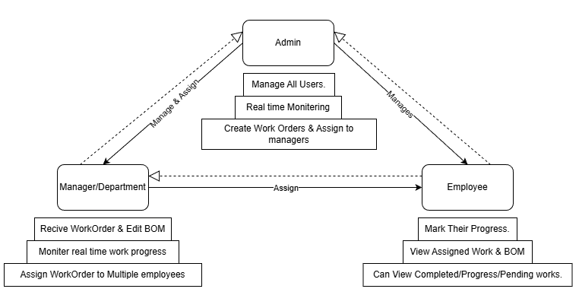
Figure 1.1
Project Schema:
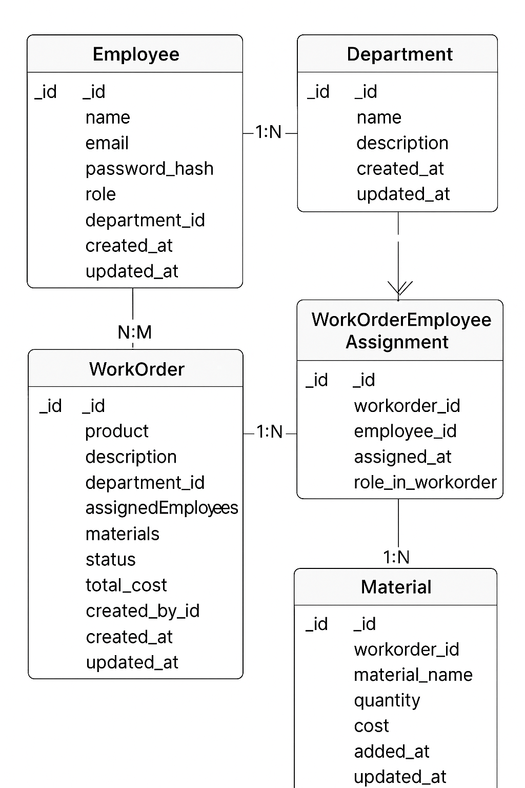
Figure 1.2
Execution Steps:

- Designed the database schema and role-based access rules.
- Implemented authentication using JWT.
- Developed APIs for Employees, Work Orders, and Departments.
- Implemented front-end UI screens for each role.
- Integrated Socket.io to broadcast updates.
- Performed testing and debugging across user flows.
- Finalized UI styling and workflow improvements.
  - Implementation, Testing & Documentation

Feature | Description
User Authentication | Login system with secure token storage
Employee Module | Admin can add/manage employees and assign roles
Work Order Module | Admin/Manager can create, assign, update work orders
Dashboard Views | Each role sees different UI elements
Status Tracking | Employees update task progress
Real-Time Alerts | Work order assignment notifications using Socket.io
Table 1.3

Challenge | Solution
Handling role-based UI and API access | Implemented JWT + Role Middleware and conditional UI rendering
Managing work order updates in real-time | Added Socket.io listeners on UI and emitters on server
Designing scalable data relations | Structured data using Mongoose models and document references
Table 1.4
  - Deployment and Maintenance
After the development and testing phases, the next step was to deploy the Employee and Work Order Management System so that it could be accessed and used by different users over the network.

Deployment Process:
The deployment was carried out in the following steps:
- Preparing the Backend
  - The backend Node.js server was configured for production mode.
  - Environment variables such as MONGO_URI, JWT_SECRET, and SOCKET_SERVER were securely stored.
  - The application was run using PM2 (or node server.js) for stability in production environments.
- Preparing the Frontend
  - The React project was built using npm run build.
  - The generated static files were served using:
    - Nginx / Apache server, or
    - Direct hosting on platforms like Vercel/Netlify.
- Database Setup
  - A cloud-based MongoDB instance (e.g., MongoDB Atlas) was set up to ensure:
    - Remote accessibility
    - Secure authentication
    - Automated backups
- Hosting
  - Backend can be deployed on services like:
    - Render / Railway / DigitalOcean / AWS EC2
  - Frontend can be deployed on:
    - Render / Netlify / GitHub Pages / Nginx static hosting
- Real-Time Communication
  - Socket.io endpoints were configured to ensure:
    - Live updates for work orders
    - Notification synchronization across Admin, Manager, and Employees

Maintenance:
Maintenance is essential to ensure the system continues to operate smoothly, securely, and efficiently. The key maintenance tasks performed include:

Maintenance Task | Description
Bug Fixing | Any issues reported during usage were traced, debugged, and resolved.
Performance Monitoring | Monitoring API response time, database query speed, and server load to optimize performance.
Database Maintenance | Ensuring database indexes are optimized and backups are regularly verified.
Security Updates | Updating npm packages, fixing vulnerabilities, and rotating security keys when needed.
User Support | Helping users understand functionality and resolving login/data access issues.
Feature Improvements | Enhancing features based on feedback from Admin/Manager/Employee roles.
Table 1.5
  - Images (field images of Internships with GPS

Chapter-4

Internships Learning’s & Findings

4.1 Types of Teams / Departments in the Firm

In a professional firm or organization, departments are usually divided based on functional specialization to ensure efficiency and smooth workflow. Common departments include:

● Management & Administration: Handles strategic planning, decision-making, policy formulation, and coordination among departments.

● Finance & Accounts: Manages financial records, budgeting, payroll, and audits.

● Human Resources (HR): Responsible for recruitment, training, performance management, and employee welfare.

● Marketing & Public Relations: Focuses on branding, promotions, social media engagement, client communication, and event coordination.

● Research & Development (R&D): Works on innovation, new product development, and continuous improvement.

● Operations / Production: Ensures day-to-day business functions, quality control, and service delivery.

● IT & Technical Support: Provides technical assistance, maintains software/hardware systems, and ensures data security.

● Customer Support / Service: Handles client or customer queries, complaints, and after-sales support.

Each team functions collaboratively toward achieving organizational goals through structured workflows and interdepartmental coordination.

4.2 Hierarchy of Roles / Posts in the Firm

Organizations follow a hierarchical structure to ensure clarity of roles, accountability, and communication. The typical hierarchy includes:

● Top Management: Board of Directors, Managing Director — responsible for vision, mission, and strategic decisions.

● Middle Management: Department Heads, Managers — responsible for planning, coordination, and supervision.

● Supervisory Level: Team Leaders, Project Leads — oversee day-to-day execution and guide junior staff.

● Operational / Executive Level: Executives, Engineers, Interns — carry out assigned tasks, reports, and contribute directly to deliverables.

During internships, students usually operate at the executive or trainee level, learning reporting systems, team dynamics, and professional communication.

4.3 Challenges Involved in the Firm

Every firm faces operational and strategic challenges that provide valuable learning experiences. Some common challenges include:

● Time Management: Balancing multiple projects with limited resources.

● Adapting to Work Culture: Understanding organizational norms and adjusting to professional expectations.

● Technology & Skill Gaps: Keeping up with evolving tools, platforms, and technical demands.

● Client Management: Handling deadlines, requirements, and maintaining professional relationships.

● Innovation Pressure: Continuous need to innovate and stay competitive in the market.

For interns, these challenges enhance adaptability, teamwork, and problem-solving skills in real-world scenarios.

4.4 Opportunities in the Firm

Internships often reveal multiple growth and learning opportunities, such as:

● Skill Development: Hands-on exposure to real projects enhances technical and managerial competencies.

● Networking: Interaction with professionals, mentors, and teams broadens one’s professional circle.

● Innovation Exposure: Opportunities to participate in creative problem-solving and project ideation.

● Career Guidance: Learning about career paths, organizational roles, and entrepreneurship possibilities.

● Leadership Development: Observation of senior management practices helps interns understand leadership styles and decision-making.

Such opportunities often motivate interns to pursue future employment or entrepreneurial ventures in similar domains.

4.5 Tools and Techniques Acquired

Full Stack Development: Gained hands-on experience in developing complete web applications using React (frontend), Node.js/Express (backend), and MongoDB (database).

Version Control & API Testing: Used Git & GitHub for code management and Postman for testing and validating RESTful APIs.

Authentication & Real-Time Communication: Implemented JWT-based security and Socket.io for live notifications and real-time data updates.

UI/UX Design & Debugging: Designed responsive interfaces using Tailwind CSS and DaisyUI, and debugged applications using Chrome DevTools.

Deployment & Maintenance: Learned to deploy applications on cloud platforms (like Render or Vercel) and perform regular updates, backups, and monitoring.

4.6 Observations & Evaluation

Internship observations typically include insights into professional environments, organizational behavior, and workflow structures. Common observations are:

● A clear chain of command and task delegation improves productivity.

● Collaborative work culture encourages innovation and idea sharing.

● Time-bound projects enhance focus and accountability.

● Use of digital tools simplifies communication and tracking.

● Mentorship helps interns align academic knowledge with industrial practices.

Evaluation: The internship experience helps evaluate personal strengths, technical gaps, and areas of improvement. It fosters growth in discipline, confidence, and practical understanding.

4.7 Conclusion

Internships act as a bridge between academic learning and professional experience. They provide exposure to real-world challenges, teamwork, and organizational dynamics. Through internships, students gain insights into career planning, skill enhancement, and workplace discipline.The overall learning outcome includes technical skill acquisition, improved communication, better problem-solving abilities, and readiness for future employment or entrepreneurship. Thus, internships play a vital role in shaping professional identity and practical competence.

